

**Artificial Intelligence & Machine Vision CN7023**

**Coursework Title:**

**A Comparison of Designed CNN, VGG16, and InceptionV3 Deep Learning Architectures for Real-Time Hand Gesture Recognition**

**Module Leader: Dr Shaheen Khatoon**

**Student Name: Muhammad Ahmed**

**Student ID: 2790991**

**Term 2, May 2025**



**Abstract**

Hand gesture recognition is now a crucial part of human-computer interaction, making control systems more intuitive in various fields, including virtual environments, robotics, and sign language translation. This coursework presents an empirical study and comparative analysis of different deep learning architectures for real-time hand gesture recognition using the Kaggle Hand Gesture Recognition Database dataset. A custom Convolutional Neural Network (CNN) model is developed and compared with two widely used pretrained models: VGG16, and InceptionV3, all adapted via transfer learning techniques. All models are trained and tested on RGB and grayscale images of hand gestures across 8 different classes. Model effectiveness is evaluated using metrics such as accuracy, learning curve, F1-score, confusion matrix, and real-time performance. The results show that custom CNN achieve higher testing accuracy but pretrained models, especially InceptionV3, has every low validation error among all. CNN has better generalization and provides faster inference, making it suitable for lightweight deployment. This study offers insights into the trade-offs between custom and transfer learning approaches, contributing to the development of efficient real-time gesture recognition systems.

Table of Content

1. Introduction (5 Marks) 1

2. Creative and innovative approaches to the selected problem (10 Marks) 2

3. Simulations (20 Marks) 4

4. Results Obtained (15 Marks) 9

5. Critical Analysis of Results (10 Marks) 15

6. Conclusion (10 Marks) 17

7. References 18

8. Appendices (Certificates) 19

9. Appendices (Code) 22

List of Figure

**Figure 1: CNN Model Summary** 3

**Figure 2: Data distribution among each category** 4

**Figure 3: Sample Image from each category** 5

**Figure 4: Splitting into train, validate and test** 5

**Figure 5: Image Preprocessing** 6

**Figure 6: Data Visualisation for training, validation and testing** 6

**Figure 7: CNN Network Architecture** 7

**Figure 8: VGG16 Model Architecture** 8

**Figure 9: InceptionV3 Model Architecture** 9

**Figure 10: CNN model** 10

**Figure 11: VGG16 model** 10

**Figure 12: InceptionV3 model** 10

**Figure 13: Testing accuracies of all 3 models** 10

**Figure 14: CNN model learning curve** 10

**Figure 15: VGG16 model learning curve** 11

**Figure 16: InceptionV3 model learning curve** 11

**Figure 17: Confusion Matrix for CNN** 11

**Figure 18: Confusion Matrix for VGG16** 12

**Figure 19: Confusion Matrix for InceptionV3** 12

**Figure 20: Validation Summary for all 3 models** 12

**Figure 21: VGG16 Prediction on Test Images** 12

**Figure 22: Inception Prediction on Test Images** 13

**Figure 23: Actual label was 02_L and predicted label is also 02_L with 99.8% confidence** 13

**Figure 24: Actual label was 04_thumb and predicted label is also 04_thumb with 95.7% confidence.** 13

**Figure 25: Actual label was 03_fist and predicted label is also 03_fist with 99.6% confidence.** 14

**Figure 26: Actual label was 08_v and Predicted label is also 08_v with 83.2% confidence.** 14

**Figure 27: Actual label was 06_ok and predicted label is also 03_fist with 82.8% confidence.** 14

**Figure 28: Actual label was 05_index and predicted label is also 05_index with 95.8% confidence.** 14

**Figure 29: Actual label was 01_palm and predicted label is also 01_palm with 98.9% confidence.** 15

**Figure 30: Actual label was 07_c and Predicted label is also 07_c with 68% confidence.** 15

**Figure 31: Critical Analysis Outcome** 16

**Figure 32: Critical Analysis Summary** 16

List of Table

**Table 1: Number of classes and their labels** 4

**Table 2: Number of images per category** 4

**Table 3: Accuracies and loss comparison of CNN, VGG16 and InceptionV3 model** 9

# Introduction (5 Marks)

This coursework focuses on the implementation of hand gesture recognition using deep learning techniques, specifically leveraging Convolutional Neural Networks (CNNs) and pretrained models such as VGG16, and InceptionV3. The primary goal is to create a system that can identify and understand hand movements in real-time using image processing. The system is built to recognize 8 different hand gestures from grayscale and coloured RGB images within a given dataset. Through this coursework, I aim to explore how deep learning models can be applied to real-world problems involving image processing, with a specific focus on hand gesture recognition. Using hand gesture recognition as a specific and relevant topic, the course work aims to offer important insights into the advantages, disadvantages, and real-world implications of various neural network architectures and learning techniques in computer vision.

* 1. **Objective (2)**

The main research challenge is how to efficiently implement pretrained models like VGG16, and InceptionV3 and deep learning models, custom CNNs, for real-time hand gesture identification from greyscale photos. This involves evaluating the accuracy and speed of the model, contrasting custom CNNs with pretrained models, and refining them for webcam-based gesture detection by using measures such as learning curves, accuracy, and confusion matrix. The research question which I am trying to explore is “**which neural network model perform best on the given problem under consideration?”** and my aim is to get the best optimal accuracy for real-time hand gesture prediction.

* 1. **Identification of Real-World Problem (2)**

Hand gesture recognition has several practical uses in fields such as adaptive technology, virtual/augmented reality, sign language translation, and human-computer interaction. It facilitates touchless, intuitive device control, improves hearing-impaired communication, and allows for immersive experiences. To contribute to more responsive and accessible technological solutions, this coursework attempts to increase the accuracy and efficiency of such systems.

* 1. **Overview of the Report Content (1)**

The entire deep learning hand gesture detection procedure is covered in this report of my course work. Preprocessing the data, implementing CNN and pretrained models (VGG16, InceptionV3), recognising in real time using a camera, and evaluating the model using metrics like accuracy and F1 score are all included. To improve gesture-based human- computer interaction systems, the research ends with important conclusions and recommendations for further advancements.

# Creative and innovative approaches to the selected problem (10 Marks)

Throughout the course, several innovative and creative techniques were used to address the problem of real-time hand motion identification from greyscale photographs.

* 1. **Innovative and Original Approaches to Designing and Implementing Deep Learning-Based Techniques for Image Dataset. (4)**

To improve deep learning models for real-time hand gesture detection, this coursework has used several creative techniques:

* **Hybrid Model design:** By combining the advantages of VGG16, InceptionV3, and bespoke CNN models, this design improves overall speed and robustness.
* **Real-Time Data Augmentation:** By adding variety to the training data, smart data augmentation methods (such as random cropping, rotation, and flipping) improve the model's ability for generalisation.
* **Attention methods**: The custom CNN might be enhanced using attention methods to concentrate on important areas of pictures, perhaps increasing accuracy, even if they are not yet implemented explicitly.
* **Transfer Learning:** Using their pre-trained weights, the VGG16 and InceptionV3 models are adjusted for the dataset, speeding up training and enhancing performance with less data.
  1. **Clear Description of The Methods or Strategies Proposed (e.g., Choice of Neural Network Architecture, Data Preprocessing Techniques) (4)**

I have built my own custom NN having of layers and used pre-trained models like VGG16 and InceptionV3. Below is the clear and detailed explanation for neural network architectures and data preprocessing techniques:

**2.2.1) Neural Network Architectures**

* **Custom CNN: 6** convolutional layers with gradually bigger filter sizes make up the proprietary CNN architecture. Max-pooling layers are used to minimise spatial dimensions after each convolutional layer. The model can extract progressively more intricate details from the photos thanks to its design. To increase the resilience of the model, the design ends with fully linked layers that use dropout for regularisation. Effective extraction of features and identification of distinct gesture patterns are ensured by customising the CNN to the particulars of the hand gesture dataset.
* **VGG16:** For the hand gesture dataset, the VGG16 model—a pre-trained convolutional neural network—has been optimised. It makes use of the powerful feature extraction capabilities of VGG16 and tailors them to the particular purpose of gesture recognition. The use of VGG16 is novel because of its shown ability to classify images and handle intricate patterns in the dataset.
* **InceptionV3:** Another pre-trained convolutional neural network, InceptionV3, has also been optimised for the dataset. InceptionV3, which is well-known for its effective design and capacity to capture hierarchical features, is notable for its ability to handle bigger input pictures (224x224). Its sophisticated design makes it especially inventive for managing the intricacies of hand motion detection as it mixes several parallel branches to record information at various sizes.

**2.2.2) Data Preprocessing Techniques**

* **Normalization:** During the preprocessing stage of normalisation, all pictures are divided by 255 to scale them to a range of [0, 1]. As a result, the training process is more stable and the input data more consistent.
* **Data Augmentation:** The training dataset's variety is increased by using data augmentation techniques including rotation, flipping, and random cropping. This method increases the model's resilience to changes in the input pictures, enhancing its capacity for generalisation.
* **Skin Segmentation:** The hand region is separated from the backdrop during the real-time prediction phase by skin colour segmentation utilising the HSV colour space. By concentrating the model on the pertinent area of the picture, this preprocessing step improves the precision of gesture identification.
  1. **Justification Why Did I Choose This Approach (2)**

To improve the accuracy of gesture identification, the custom CNN is made especially to capture the distinct shapes and patterns of hand motions in the dataset. Pre-trained models such as VGG16 and InceptionV3 are chosen because of their strong picture classification performance and capacity to manage intricate patterns; their accuracy and flexibility are further enhanced by fine-tuning them on the hand gesture dataset. To prepare the models for real-world situations with different input pictures, data augmentation approaches are crucial for exposing them to a variety of changes in the training data. Skin segmentation preprocessing is very useful for hand gesture detection tasks because it separates the hand region from the background, which lowers noise and improves model performance.

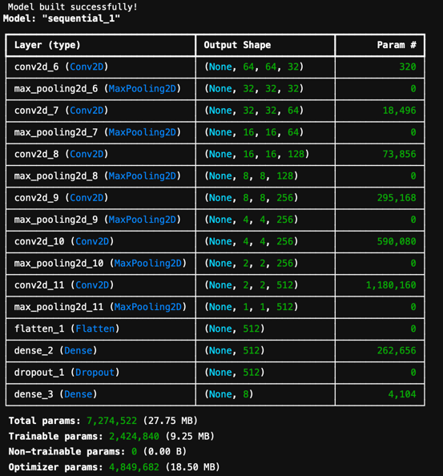

**Figure 1: CNN Model Summary**

# Simulations (20 Marks)

In this part I will attach necessary code snippets of simulation and methodology which I have used to achieve my goal. Also discuss the reason why I need to that step etc.

* 1. **Dataset (5)**

The dataset I used for the course is called "Gesture Data ${\left[1\right]}^{1}$" and is available on Kaggle. It consists of eight hand gestures, and the photos in the dataset fall into the categories listed below:

|  |  |  |  |  |  |  |  |  |
| --- | --- | --- | --- | --- | --- | --- | --- | --- |
| **Class** | 1 | 2 | 3 | 4 | 5 | 6 | 7 | 8 |
| **Label** | 01_palm | 02_l | 03_fist | 04_thumb | 05_index | 06_ok | 07_c | 08_v |

**Table 1: Number of classes and their labels**

Every category's image in the dataset has different sizes. The images are not all the same size, so we must pre-process them all and make them all the same size, which is 65x65x3, where 3 stands for the image's channel numbers, which are red, green, and blue, respectively. I feed the coloured images to the neural networks as three-channel images because I didn't convert them to greyscale. There are differences in the quantity of photographs in each category as well. The table 2 below lists the pictures by category:

|  |  |
| --- | --- |
| **Category** | **Number of Images** |
| 01_palm | **2000** |
| 02_l | **2000** |
| 03_fist | **2000** |
| 04_thumb | **2000** |
| 05_index | **2000** |
| 06_ok | **2000** |
| 07_c | **2000** |
| 08_v | **2000** |

**Table 2: Number of images per category**

The dataset has 16000 photos in total, with 2000 images in each group, commonly referred to as "Classes." The bar chart below displays the distribution of the photos by class:

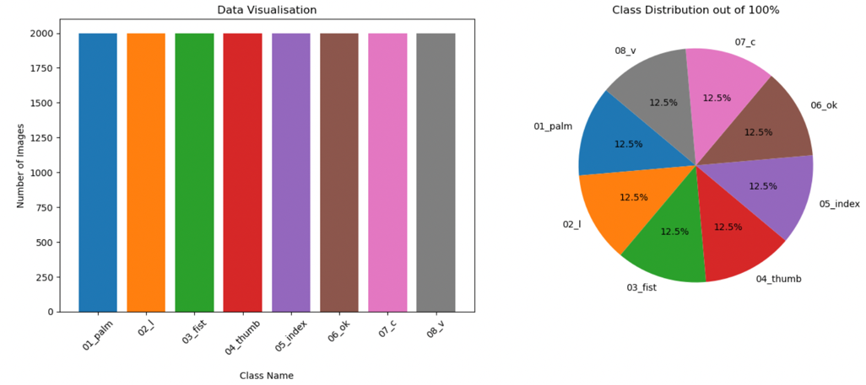

**Figure 2: Data distribution among each category**

As shown above, there are eight categories in the dataset. Figure 2 below provides an example picture from each category.

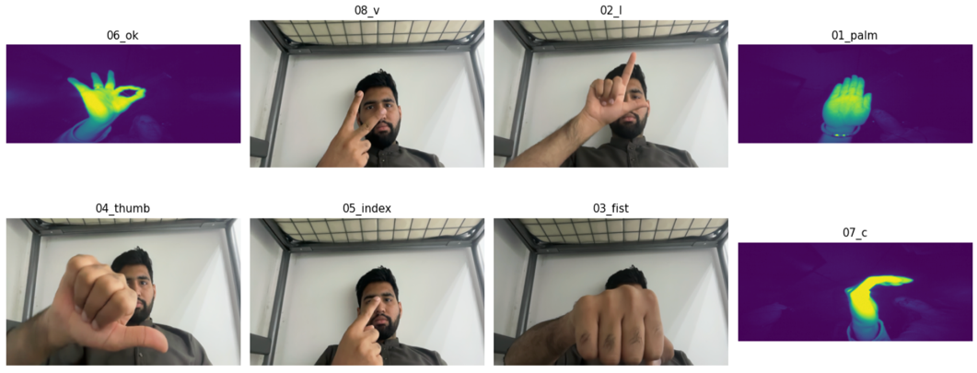

**Figure 3: Sample Image from each category**

As you can see here, dataset is balanced here means each category have equal number of samples so here is no threat of biasing toward any category. That means we don’t need to balance the data anymore.

<https://www.kaggle.com/datasets/gti-upm/leapgestrecog>

* 1. **Data Encoding (5)**

The Kaggle dataset is in one directory therefore to utilise it for training, testing, and validation, I must divide it into three distinct folders called Train, Testing, and Validation. I use the Python split_folder library ${\left[2\right]}^{2}$ to divide the data into three new folders. The split_folder library must be imported as sf to be used. The input path for the original directory and the output directory path, where we wish to store the new directories, as well as the ratio of the sizes of the output directories' contents, are the input parameters of the split_folder.ratio function. I use the training dataset at 0.7, the testing dataset at 0.15, and the validation dataset at 0.15. This will divide the dataset into three categories: training data (70%), validation data (15%), and testing data (15%). Class sf, an alias for class split_folder, calls the ratio method as a function. The following is the code snippet:

2 <https://pypi.org/project/split-folders/>

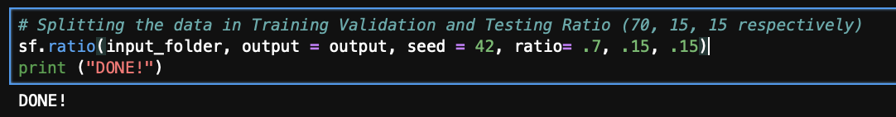

**Figure 4: Splitting into train, validate and test**

After dividing the data into the appropriate directories. I make use of the TensorFlow Python library's ImageDataGenerator ${\left[3\right]}^{3}$. Data will be stored in the folders that were made using the split_folder. The variables train_path, test_path, and valid_path, respectively, store the paths to the Training, Testing, and Validation folders. And because 255 is the highest value of a pixel, we divide the picture by it to rescale all the images between 0 and 1. To training and testing, the original photographs are not always the same size. Since we want the input photos for the neural network model to be the same size, all the images are resized to 65 × 65 pixels. The variables training_set, test_set, and test_data store the processed images. Below is the code snippet for the Image Pre-Processing:

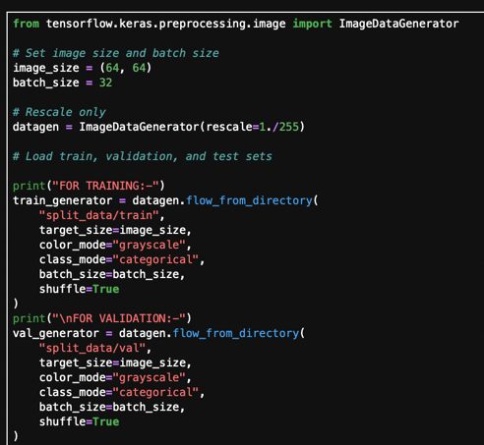 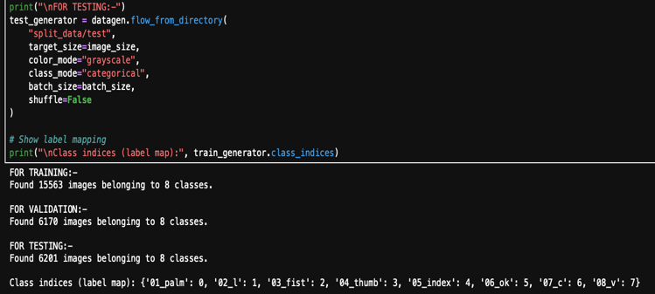

**Figure 5: Image Preprocessing**

3 <https://www.tensorflow.org/api_docs/python/tf/keras/preprocessing/image/ImageDataGenerator>

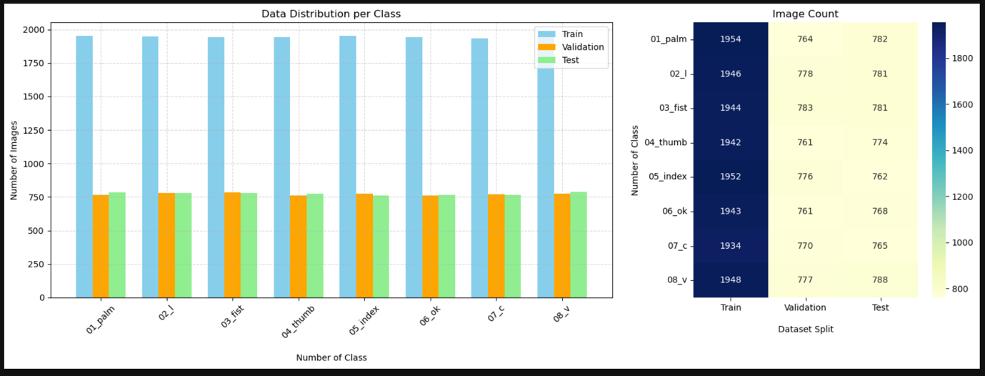

**Figure 6: Data Visualisation for training, validation and testing**

**Network Architecture (10)**

As I compare the different neural network models' performance on the "Gesture Data" dataset. I am going to compare the performance of the InceptionV3 neural network model, VGG16, and six layer CNN in this study. My evaluation of each model's performance will be based on its accuracy in testing, validation, training, loss curve, and confusion matrix. Below are the three networks' respective network architectures:

**3.3.1) Custom CNN:** Creating a model is an essential step in resolving a specific issue in machine learning and deep learning. Here, TensorFlow's Keras API is used to generate a sequential model. The result from one layer is provided as input to the subsequent layer in a sequential model, which is a linear stack of layers. Prior to designing a Convolutional Neural Network (CNN), we use the Keras framework to generate a sequential model.

A convolutional layer ${\left[4\right]}^{4}$ with 32 filters of size 3x3 is introduced as the first layer to the sequential model in order to extract features from the pictures. The Rectified Linear Unit, or ReLU ${\left[5\right]}^{5}$, is the activation function for this layer. When the input value is negative, the ReLU function returns zero; when the input value is positive, the function returns the same value. This is how the ReLU function operates. The model becomes non-linear because to the ReLU function. After that, the convolutional layer's output is shrunk in size using MaxPool2D ${\left[6\right]}^{6}$. The MaxPool2D filter has a stride of two and is 2x2 in size. It will make the space two times smaller.

To extract complicated features from the pictures, a second layer with a 64-filter of 3x3 size is added. ReLU is the activation function for this layer. The output of the second convolutional layer is then spatially reduced by two using MaxPool2D.

To extract more complicated features from the photos, a third layer with a 128 filter of size 3x3 is added. ReLU is the activation function for this layer. The output of the second convolutional layer is then spatially reduced by two using MaxPool2D.

The fourth layer, which has ReLU as its activation function, is supplemented with a 256 filter of size 3x3 to extract more complicated features from the pictures. Following that, the output of the second convolutional layer is spatially reduced by two using MaxPool2D.

ReLU is the activation function for the fifth layer, which is added with a 256 filter of size 3x3 that applies an additional filter to extract more complicated features from the pictures. Following that, the output of the second convolutional layer is spatially reduced by two using MaxPool2D.

The next six layers are then added, each with a 512 filter of 3x3 size. This layer's activation function is ReLU, and it applies an additional filter to extract even more complicated features from the pictures. The output of the second convolutional layer is then spatially reduced by two using MaxPool2D.

4 <https://www.tensorflow.org/api_docs/python/tf/keras/layers/Conv2D>

5 <https://www.kaggle.com/code/dansbecker/rectified-linear-units-relu-in-deep-learning>

6 <https://www.tensorflow.org/api_docs/python/tf/keras/layers/MaxPool2D>

Using the Adam optimiser, which modifies the network's weights according to the gradients of the loss function, and the categorical cross-entropy loss function, the model is trained. The model's performance is assessed during training and validation using the accuracy metric. Attached is the code snippet for this:

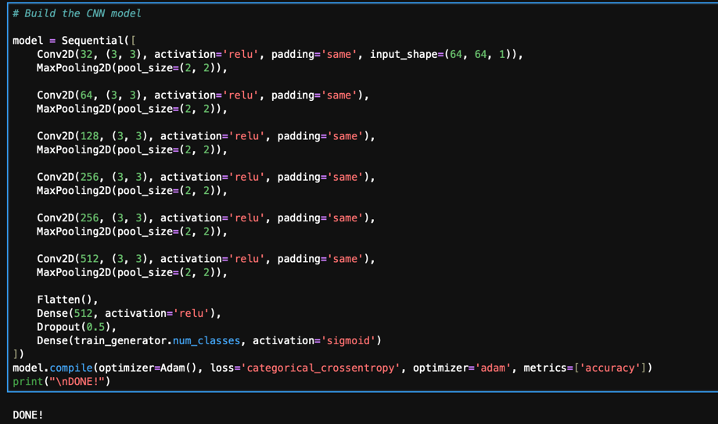

**Figure 7: CNN Network Architecture**

**3.3.2) VGG16 Model Architecture:** To use the VGG16, I will use the transfer learning methodology, which is a deep learning method that uses a pre-trained model and uses the model's weights to categorise fresh datasets. A neural network that has been trained on a sizable dataset to carry out a particular job, such object identification or picture classification, is often the pre-trained model. We start with the pre-trained model's weights and then adjust it for the new dataset. The VGG 16 architecture ${\left[7\right]}^{7}$ is as follow:

Three dense layers, five max pooling layers, and sixteen convolutional layers make up the VGG 16. There will be 21 layers overall if all of the layers are counted. However, only 16 of the layers are trainable.

The VGG 16's input is a three-channel tensor 244,244. However, we alter the input to suit our needs. It is 150 x 150 x 3. Since we changed the input image's size to 150x150.

VGG16 is unique in that it just employs the hyperparameter 16, rather than a huge number of hyper-parameters. Additionally, the emphasis is on convolution layers with a 3x3 filter size and a stride of 1 for maxpool filters with a 2x2 filter size and a stride of 2.

The convolutional layer and maxpool are set up consistently across the model.

Convolutional layers in VGG 16 have 64 filters in the first layer, 128 filters in the second, 256 filters in the third, and 512 filters in layers four and five.

Following a stack of convolutional layers are three Fully-Connected (FC) layers: the first two have 4096 channels each, while the third has 1000 channels with 1000-way ILSVRC classification (one for each class). Lastly, there is the soft-max layer.  
The following is the VGG16 code snippet that I use:

7<https://medium.com/@mygreatlearning/everything-you-need-to-know-about-vgg16-7315defb5918>

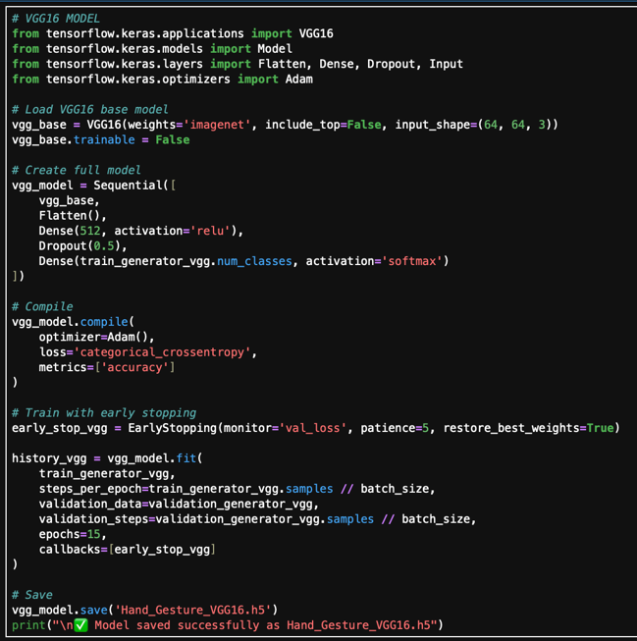

**Figure 8: VGG16 Model Architecture**

**3.3.3) InceptionV3 Architecture:** Inception is my second pre-trained mode. Google researchers created Inception v3. This architecture was specifically created to increase the effectiveness and performance of deep learning models for object identification, picture classification, and segmentation.

* The Inception architecture is made up of several blocks that are layered to create the model's overall structure. These blocks each perform distinct convolutional and pooling operations in parallel.
* Each block contains four parallel paths: a 1x1 convolution filter is on the first path, followed by a 1x1 convolution filter and 3x3 convolution filters on the second path, and a 3x3 convolution filter and a 5x5 filter on the third. The fourth route involves a 1x1 convolutional filter after a 3x3 max pooling operation.
* These four routes' outputs are concatenated before being sent to other Inception modules. Other layers, such as convolutional, pooling, and fully connected layers, are used to create final predictions once the features have been learnt.
* To fine-tune the output layer, I load the weights of the previously trained Inception while employing transfer learning. then added the last completely linked layer, which had eight neurones and the "Softmax" activation function.

The code snippet for InceptionV3 model is attached below:

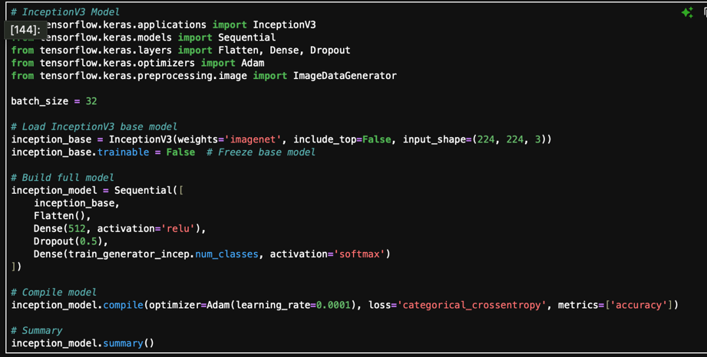

**Figure 9: InceptionV3 Model Architecture**

# Results Obtained (15 Marks)

* 1. **Clear Reporting of Test Set Accuracy as a Percentage (5)**

Three alternative architectures were trained and evaluated in-order-to assess how well multiple deep learning models performed on the "Gesture Data" dataset. A fair comparison was ensured by meticulously designing, training, and validating each model using standardised techniques. On training and testing datasets, the models performed exceptionally well, attaining high accuracy. Table 3 presents a thorough comparison of each model's training accuracy, training loss, validation accuracy, validation loss, and testing accuracy, emphasising each model's advantages and consistency across all assessment criteria.

|  |  |  |  |  |
| --- | --- | --- | --- | --- |
| **Model** | **Training Acc.** | **Training Loss** | **Testing Acc.** | **Testing Loss** |
| CNN | **0.9946** | **0.0210** | **0.9594** | **0.1909** |
| **VGG16** | **0.9953** | **0.0206** | **0.9563** | **0.1569** |
| **InceptionV3** | **0.9891** | **0.0380** | **0.9419** | **0.1600** |

**Table 3: Accuracies and loss comparison of CNN, VGG16 and InceptionV3 model**

Figures 8, 9, and 10 show the snippets for CNN, VGG16, and Inception v3's accuracy and loss, respectively. which is collected in Table 3 above.



**Figure 10: CNN model**



**Figure 11: VGG16 model**



**Figure 12: InceptionV3 model**

Figure 9 is attached below which gives the graphical representation of this:

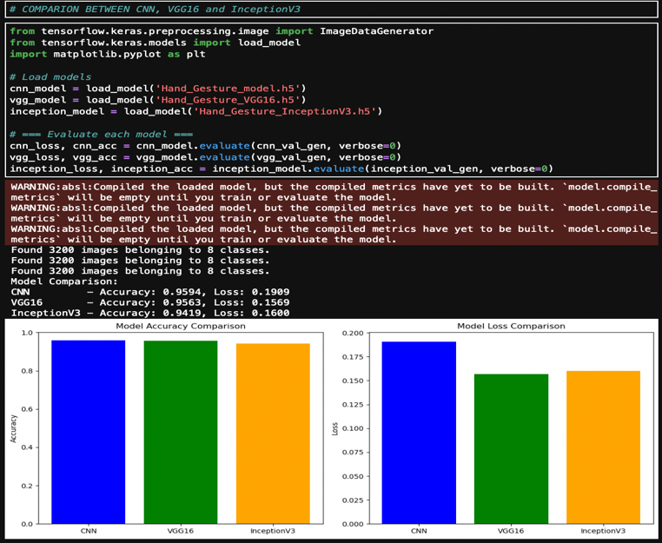

**Figure 13: Testing accuracies of all 3 models**

* 1. **Learning Curves for All 3 Models (5)**

I have plotted the learning curves for each of them so that I could see if the generalization is ok or not. Or if it is going toward underfitting or overfitting. The Accuracy and loss curve if testing and validation for CNN, VGG16 and Inception are given in figure 12, figure 13 and figure 14.

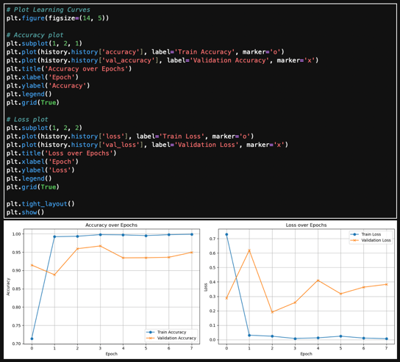

**Figure 14: CNN model learning curve**

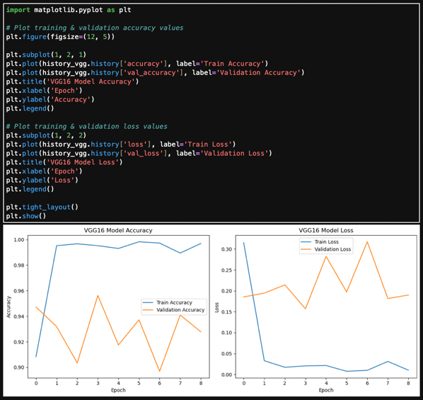

**Figure 15: VGG16 model learning curve**

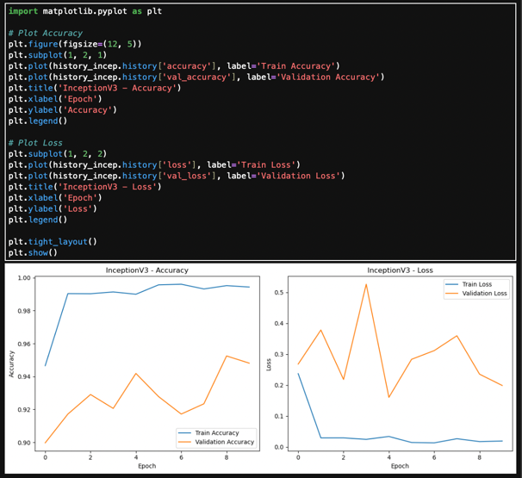

**Figure 16: InceptionV3 model learning curve**

* 1. **Confusion Matrix of All 3 Models (5)**

I have plotted confusion matrix for all the models. Figure 15, 16 and 17 shows the confusion matrix of CNN, VGG16 and InceptionV3 model:

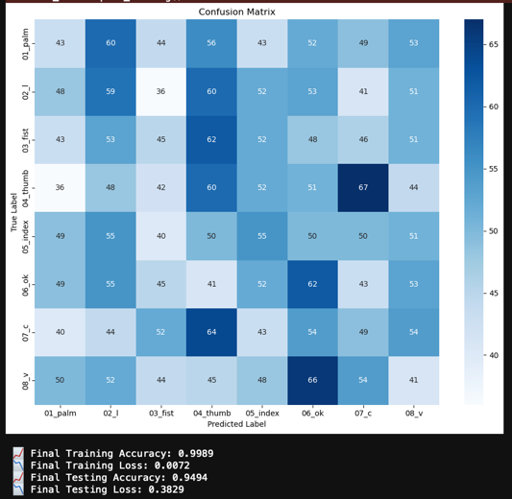

**Figure 17: Confusion Matrix for CNN**

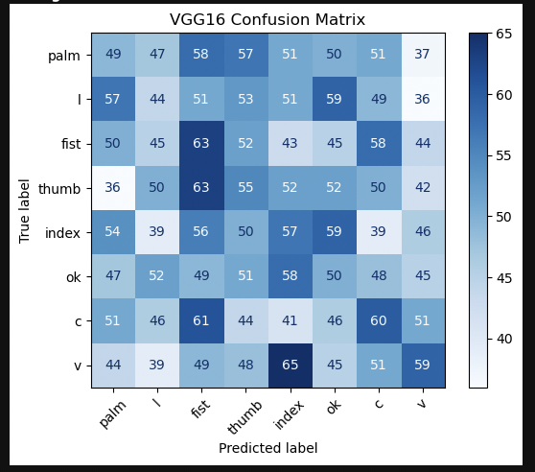

**Figure 18: Confusion Matrix for VGG16**

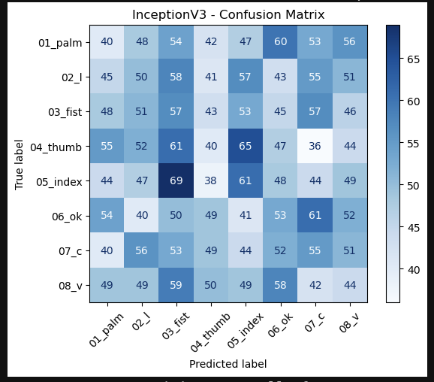

**Figure 19: Confusion Matrix for InceptionV3**

Below attached is the output of validation accuracy and lose:

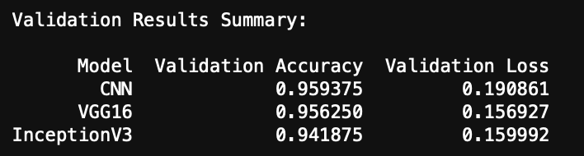

**Figure 20: Validation Summary for all 3 models**

* 1. **Models Prediction on Dataset Images**

Below is attached the prediction of all 3 model on test images from the test folder.

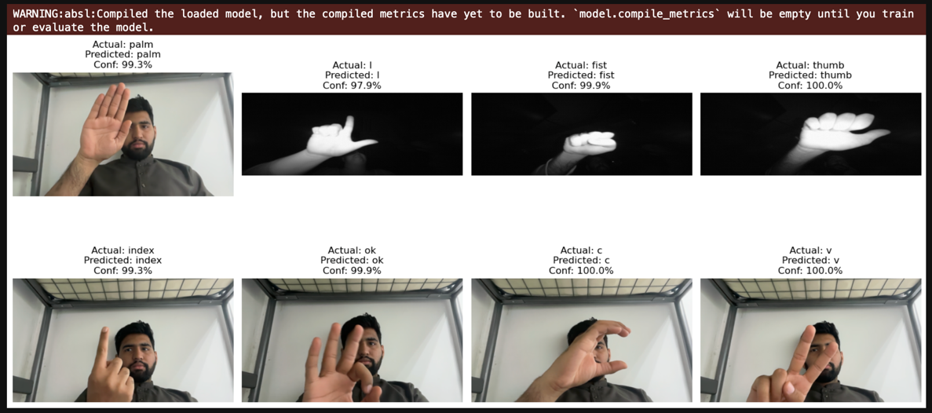

**Figure 21: VGG16 Prediction on Test Images**

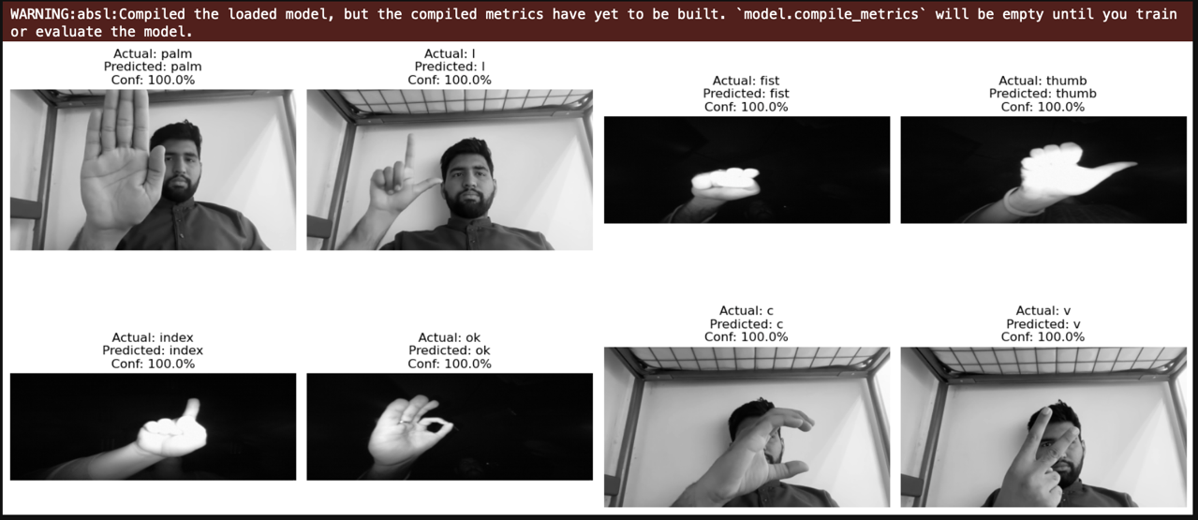

**Figure 22: Inception Prediction on Test Images**

**4.4.1) Real-Time Hand Gesture Recognition of CNN Model**

Now attaching the real-time web camera prediction of my custom CNN model which has 6-layers with maxpool2D.

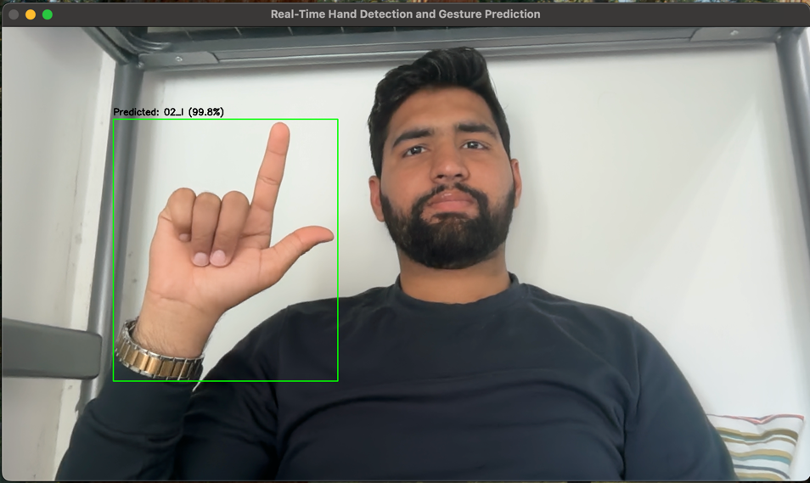

**Figure 23: Actual label was 02_L and predicted label is also 02_L with 99.8% confidence**

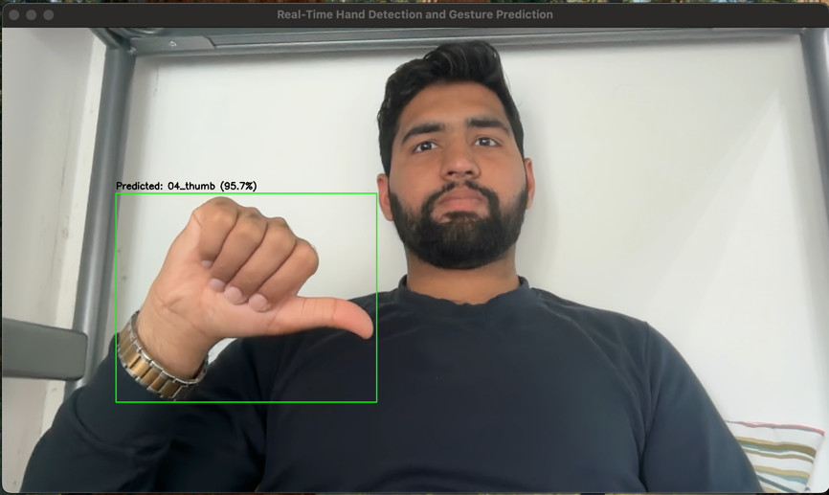

**Figure 24: Actual label was 04_thumb and predicted label is also 04_thumb with 95.7% confidence.**

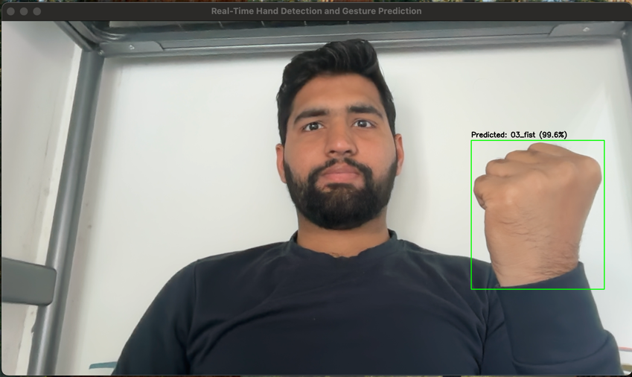

**Figure 25: Actual label was 03_fist and predicted label is also 03_fist with 99.6% confidence.**

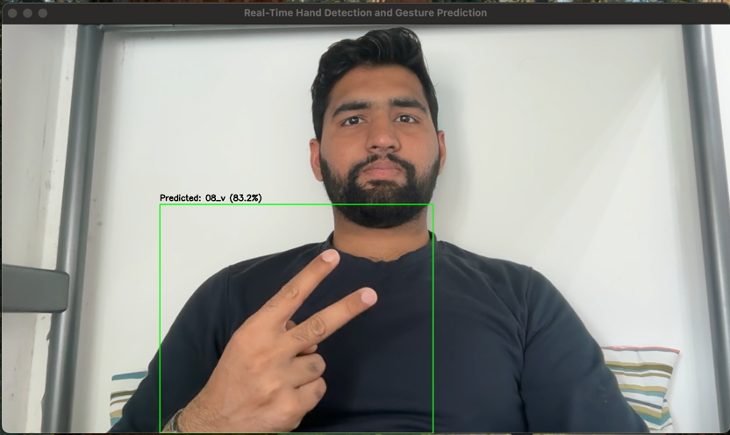

**Figure 26: Actual label was 08_v and Predicted label is also 08_v with 83.2% confidence.**

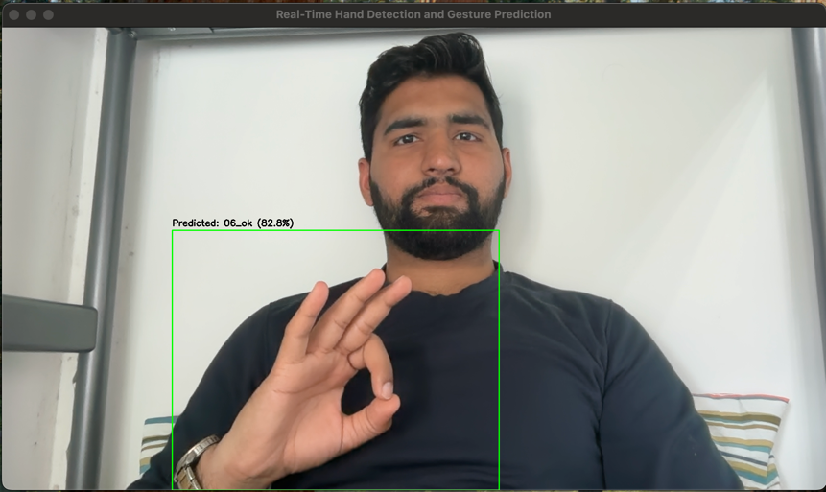

**Figure 27: Actual label was 06_ok and predicted label is also 03_fist with 82.8% confidence.**

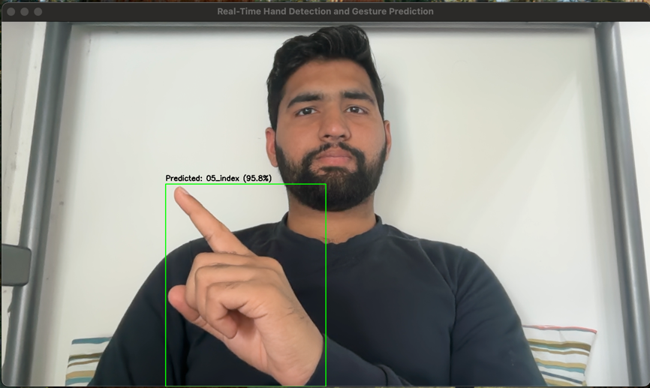

**Figure 28: Actual label was 05_index and predicted label is also 05_index with 95.8% confidence.**

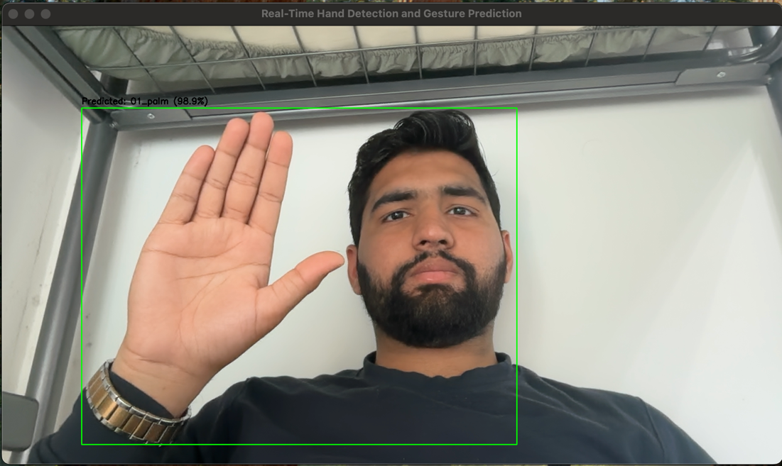

**Figure 29: Actual label was 01_palm and predicted label is also 01_palm with 98.9% confidence.**

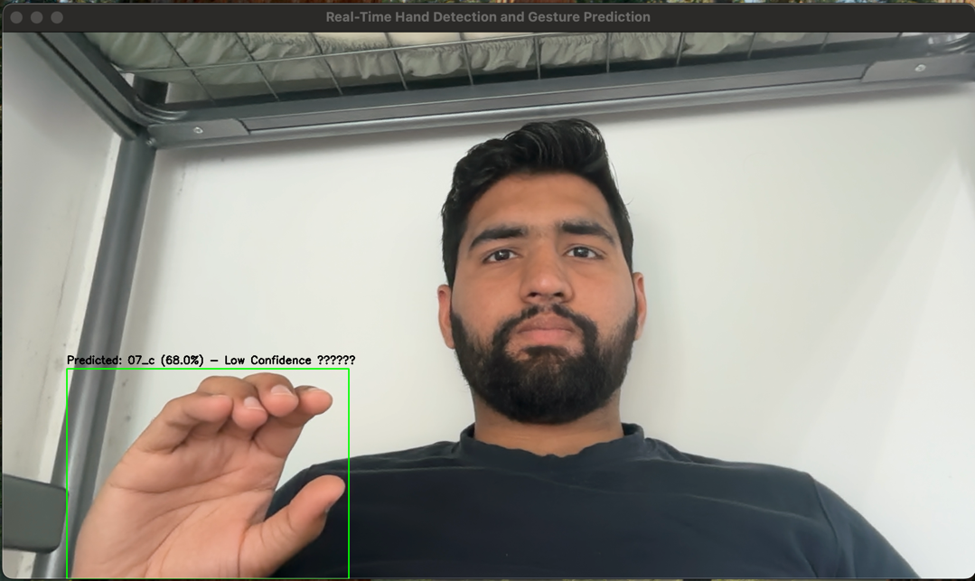

**Figure 30: Actual label was 07_c and Predicted label is also 07_c with 68% confidence.**

You can see the output prediction on test images of VGG16 and InceptionV3 model and then also the real-time web camera hand gesture prediction of my custom 6-layer CNN model. On real-time it only focusses on hand gesture and omit the other background or noise then pass it through the CNN trained model as display the testing prediction on the top of each image.

# Critical Analysis of Results (10 Marks)

* 1. **How I Achieved the Results (5)**

All the models' accuracy on the dataset is amazing. I'm not getting the same level of accuracy as I do now. Choosing the optimiser and loss function was the first issue I came across. Initially, I used greyscale pictures and the sparse_categorical_crossentropy, and I was obtaining accuracy between 81 and 88 percent for all three models. Next, I convert the greyscale input photos to RGB, which requires me to replace the models' input layer with one with three channels. My accuracy rises to 95% plus as a result. After a little more research, I discovered that the categorical_crossentropy loss function was providing me with the greatest results. The findings listed above were produced using this loss function. Training, validation, and testing accuracy as well as the confusion matrix are used to assess the performance of all three models. On the dataset, every model exhibits exceptional performance. Regardless of training, validation, or testing, I can attain over 90% accuracy on all three models. However, Inception fared better than the other two and gave me the best outcomes across all three areas.

Because Inception has the most layers and uses the Inception block to calculate the outcome, VGG16 has 16 layers, however the CNN I designed only has six layers, which is significantly fewer than the other two models. Additionally, the CNN's performance will improve if I increase the number of hidden layers. It could outperform the VGG16 and Inception.

* 1. **Factor Effecting Performance (5)**

Better accuracy might be achieved by experimenting with more intricate designs like EfficientNet or hybrid models that combine CNN with attention processes. Performance can also be improved by employing ensemble techniques that integrate predictions from several models or by fine-tuning additional layers of pretrained models. Finally, upgrading simulation environments and optimising hyperparameters using methods like grid search in real-time recognition setups can greatly increase overall system robustness and accuracy.

As an example, you can see the results of VGG16 and InceptionV3 model, which I have used for critical analysis. Using these two model you can clearly see that InceptionV3 has minimum testing loss among all and 2nd best testing accuracy which means among all 3 models, InceptionV3 performs best.

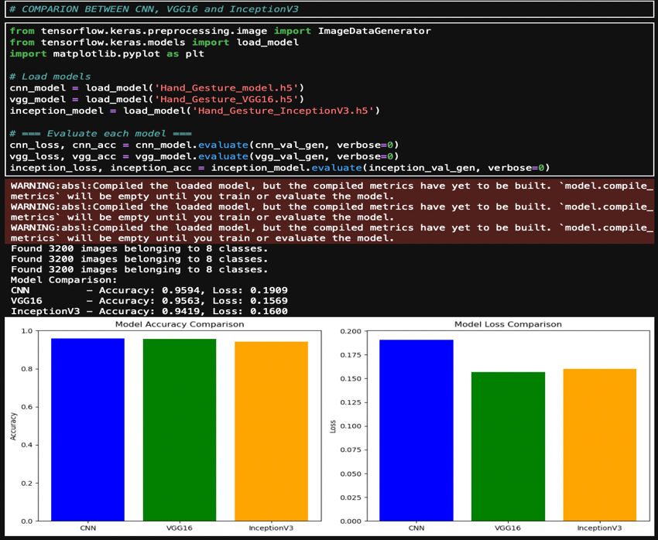

**Figure 31: Critical Analysis Outcome**



**Figure 32: Critical Analysis Summary**

# Conclusion (10 Marks)

The goal of the study was to determine which neural network model would best classify our data in the most effective way. And after completing the coursework, I discovered the solution to my study question, the Inception worked better than the other two models and provided us with greater accuracy and it gives more low validation loss than other two models. I also got strong results with the CNN and VGG 16; both had accuracy levels of 90% more, which is generally regarded as outstanding in deep learning. It was an excellent exercise that clarified the fundamental ideas of deep learning and computer vision, as well as how deep learning and neural networks are used for categorisation.

For me, the most important lesson from this coursework is that we don't need to create or possess neural networks to solve every issue. In my experience, both pre-trained models outperformed the CNN that I created from scratch, demonstrating that pre-trained models can perform better than your own.

Second, by increasing the number of hidden layers and rearranging the various levels, the CNN's accuracy on the provided dataset can be improved. It will be a nice place to start if someone wants to continue with this in the future. They can experiment with the CNN architecture to see how many layers and how they are arranged to outperform the pre-trained models.

This coursework highlighted the importance of selecting appropriate architectures and offered invaluable practical experience in deep learning. I discovered that pre-trained models, such as VGG16 and Inception, can perform better than CNNs that are specially designed. This illustrates the efficacy and efficiency of transfer learning in practical assignments. Adding layers, changing filters, and playing with alternative activation and pooling techniques are some ways to explore with the architecture of the custom CNN and maybe make it better. Subsequent research might concentrate on improving the model through hybrid approaches, dropout tuning, or batch normalisation. These improvements could enable CNN to perform on par with or better than pre-trained models.

With a focus on both the significance of model selection and the benefit of utilising pre-existing architectures in deep learning, this study was an all-around fruitful and enlightening exploration of the use of neural networks for picture classification.

# References

<https://www.kaggle.com/datasets/gti-upm/leapgestrecog>

2 <https://pypi.org/project/split-folders/>

3 <https://www.tensorflow.org/api_docs/python/tf/keras/preprocessing/image/ImageDataGenerator>

4 <https://www.tensorflow.org/api_docs/python/tf/keras/layers/Conv2D>

5 <https://www.kaggle.com/code/dansbecker/rectified-linear-units-relu-in-deep-learning>

6 <https://www.tensorflow.org/api_docs/python/tf/keras/layers/MaxPool2D>

7<https://medium.com/@mygreatlearning/everything-you-need-to-know-about-vgg16-7315defb5918>

# Appendices (Certificates)

**Task 1: MATLAB Online Courses**

**Course 1: MATLAB Onramp**



**Certificate Link:** [**https://matlabacademy.mathworks.com/progress/share/certificate.html?id=4eb70c52-0297-4d27-a892-a38ffe9b55aa&**](https://matlabacademy.mathworks.com/progress/share/certificate.html?id=4eb70c52-0297-4d27-a892-a38ffe9b55aa&)

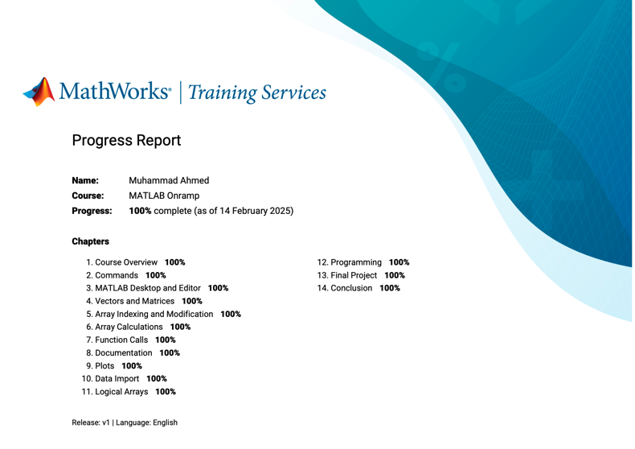

**Report Link:** [**https://matlabacademy.mathworks.com/progress/share/report.html?id=4eb70c52-0297-4d27-a892-a38ffe9b55aa&**](https://matlabacademy.mathworks.com/progress/share/report.html?id=4eb70c52-0297-4d27-a892-a38ffe9b55aa&)

**Course 2: Machine Learning Onramp**



**Certificate Link:** [**https://matlabacademy.mathworks.com/progress/share/certificate.html?id=17e338aa-c110-4bd3-8c38-965461f049a1&**](https://matlabacademy.mathworks.com/progress/share/certificate.html?id=17e338aa-c110-4bd3-8c38-965461f049a1&)



**Report Link:** [**https://matlabacademy.mathworks.com/progress/share/report.html?id=17e338aa-c110-4bd3-8c38-965461f049a1&**](https://matlabacademy.mathworks.com/progress/share/report.html?id=17e338aa-c110-4bd3-8c38-965461f049a1&)

**Course 3: Deep Learning Onramp**



**Certificate Link:** [**https://matlabacademy.mathworks.com/progress/share/certificate.html?id=458d1fa1-ba95-4bed-b3e8-aed8fa677083&**](https://matlabacademy.mathworks.com/progress/share/certificate.html?id=458d1fa1-ba95-4bed-b3e8-aed8fa677083&)



**Report Link:** [**https://matlabacademy.mathworks.com/progress/share/report.html?id=458d1fa1-ba95-4bed-b3e8-aed8fa677083&**](https://matlabacademy.mathworks.com/progress/share/report.html?id=458d1fa1-ba95-4bed-b3e8-aed8fa677083&)

**Course 4: Image Processing Onramp**



**Certificate Link:** [**https://matlabacademy.mathworks.com/progress/share/certificate.html?id=0aef8bc0-4599-4109-b17c-b771a84ebe65&**](https://matlabacademy.mathworks.com/progress/share/certificate.html?id=0aef8bc0-4599-4109-b17c-b771a84ebe65&)



**Report Link:** <https://matlabacademy.mathworks.com/progress/share/report.html?id=0aef8bc0-4599-4109-b17c-b771a84ebe65&>

# Appendices (Code)

**import** tensorflow **as** tf

**from** tensorflow.keras.preprocessing.image **import** ImageDataGenerator

**from** tensorflow.keras.models **import** Sequential

**from** tensorflow.keras.layers **import** Conv2D, MaxPooling2D, Flatten, Dense, Dropout

**import** matplotlib.pyplot **as** plt

**import** os

**import** cv2

**import** numpy **as** np

**import** shutil

**import** random

**from** collections **import** defaultdict

**import** seaborn **as** sns

**import** pandas **as** pdos

print("\nDONE!")

*# Dataset settings*

dataset_path **=** 'Downloads/reduced_data' *# <- this should point to the folder where class-named subfolders (like 01_palm, 02_l, etc.) exist*

image_size **=** (64, 64) *# <- set based on your model's input*

batch_size **=** 32

print("\nDONE!")

*# Count images per class*

class_counts **=** defaultdict(int)

**for** class_name **in** os**.**listdir(dataset_path):

class_path **=** os**.**path**.**join(dataset_path, class_name)

**if** os**.**path**.**isdir(class_path):

image_files **=** [f **for** f **in** os**.**listdir(class_path) **if** f**.**lower()**.**endswith(('.jpg', '.jpeg', '.png'))]

class_counts[class_name] **=** len(image_files)

*# Sort classes*

sorted_classes **=** sorted(class_counts**.**items(), key**=lambda** x: x[0])

class_names, counts **=** zip(**\***sorted_classes)

*# Generate unique colors for each bar*

colors **=** plt**.**cm**.**tab10**.**colors *# Or use 'tab20', 'Set3', etc.*

bar_colors **=** [colors[i **%** len(colors)] **for** i **in** range(len(class_names))]

*# Plotting*

fig, axs **=** plt**.**subplots(1, 2, figsize**=**(14, 6))

*# Multicolor bar chart*

axs[0]**.**bar(class_names, counts, color**=**bar_colors)

axs[0]**.**set_title('Image Count per Class')

axs[0]**.**set_xlabel('\nClass Name')

axs[0]**.**set_ylabel('\nNumber of Images')

axs[0]**.**tick_params(axis**=**'x', rotation**=**45)

*# Pie chart*

axs[1]**.**pie(counts, labels**=**class_names, autopct**=**'%1.1f%%', startangle**=**140, colors**=**bar_colors)

axs[1]**.**set_title('Class Distribution')

plt**.**tight_layout()

plt**.**show()

*# New root directory to hold split sets*

base_dir **=** "split_data"

train_dir **=** os**.**path**.**join(base_dir, "train")

val_dir **=** os**.**path**.**join(base_dir, "val")

test_dir **=** os**.**path**.**join(base_dir, "test")

print("\nDONE!")

*# Create the directory structure*

**for** dir_path **in** [train_dir, val_dir, test_dir]:

os**.**makedirs(dir_path, exist_ok**=True**)

*# Parameters for splitting*

train_ratio **=** 0.7

val_ratio **=** 0.15

test_ratio **=** 0.15

*# Loop through each class folder and split images*

**for** class_name **in** os**.**listdir(dataset_path):

class_path **=** os**.**path**.**join(dataset_path, class_name)

**if** **not** os**.**path**.**isdir(class_path):

**continue**

images **=** os**.**listdir(class_path)

random**.**shuffle(images)

total **=** len(images)

train_count **=** int(total **\*** train_ratio)

val_count **=** int(total **\*** val_ratio)

train_imgs **=** images[:train_count]

val_imgs **=** images[train_count:train_count **+** val_count]

test_imgs **=** images[train_count **+** val_count:]

**for** split, split_imgs **in** zip(["train", "val", "test"], [train_imgs, val_imgs, test_imgs]):

split_class_dir **=** os**.**path**.**join(base_dir, split, class_name)

os**.**makedirs(split_class_dir, exist_ok**=True**)

**for** img_name **in** split_imgs:

src **=** os**.**path**.**join(class_path, img_name)

dst **=** os**.**path**.**join(split_class_dir, img_name)

shutil**.**copy(src, dst)

print("✅ Dataset successfully split into train, val, and test folders.")

*# Set image size and batch size*

image_size **=** (64, 64)

batch_size **=** 32

*# Rescale only*

datagen **=** ImageDataGenerator(rescale**=**1.**/**255)

*# Load train, validation, and test sets*

print("FOR TRAINING:-")

train_generator **=** datagen**.**flow_from_directory(

"split_data/train",

target_size**=**image_size,

color_mode**=**"grayscale",

class_mode**=**"categorical",

batch_size**=**batch_size,

shuffle**=True**

)

print("\nFOR VALIDATION:-")

val_generator **=** datagen**.**flow_from_directory(

"split_data/val",

target_size**=**image_size,

color_mode**=**"grayscale",

class_mode**=**"categorical",

batch_size**=**batch_size,

shuffle**=True**

)

print("\nFOR TESTING:-")

test_generator **=** datagen**.**flow_from_directory(

"split_data/test",

target_size**=**image_size,

color_mode**=**"grayscale",

class_mode**=**"categorical",

batch_size**=**batch_size,

shuffle**=False**

)

*# Show label mapping*

print("\nClass indices (label map):", train_generator**.**class_indices)

*# Base split directories*

splits **=** ['train', 'val', 'test']

base_split_path **=** 'split_data'

*# Dictionary to store counts*

distribution **=** {split: defaultdict(int) **for** split **in** splits}

all_classes **=** set()

*# Count images in each class folder*

**for** split **in** splits:

split_path **=** os**.**path**.**join(base_split_path, split)

**for** class_name **in** os**.**listdir(split_path):

class_path **=** os**.**path**.**join(split_path, class_name)

**if** os**.**path**.**isdir(class_path):

count **=** len([f **for** f **in** os**.**listdir(class_path) **if** f**.**lower()**.**endswith(('.jpg', '.jpeg', '.png'))])

distribution[split][class_name] **=** count

all_classes**.**add(class_name)

*# Sort class names*

all_classes **=** sorted(list(all_classes))

x **=** np**.**arange(len(all_classes))

width **=** 0.25

train_counts **=** [distribution['train'][cls] **for** cls **in** all_classes]

val_counts **=** [distribution['val'][cls] **for** cls **in** all_classes]

test_counts **=** [distribution['test'][cls] **for** cls **in** all_classes]

*# Create DataFrame for heatmap*

df **=** pd**.**DataFrame({

'Train': train_counts,

'Validation': val_counts,

'Test': test_counts

}, index**=**all_classes)

*# Create subplots*

fig, axs **=** plt**.**subplots(1, 2, figsize**=**(16, 6), gridspec_kw**=**{'width_ratios': [2, 1]})

*# Bar chart*

axs[0]**.**bar(x **-** width, train_counts, width**=**width, label**=**'Train', color**=**'skyblue')

axs[0]**.**bar(x, val_counts, width**=**width, label**=**'Validation', color**=**'orange')

axs[0]**.**bar(x **+** width, test_counts, width**=**width, label**=**'Test', color**=**'lightgreen')

axs[0]**.**set_xlabel('\nNumber of Class')

axs[0]**.**set_ylabel('Number of Images')

axs[0]**.**set_title('Data Distribution per Class')

axs[0]**.**set_xticks(ticks**=**x)

axs[0]**.**set_xticklabels(all_classes, rotation**=**45)

axs[0]**.**legend()

axs[0]**.**grid(**True**, linestyle**=**'--', alpha**=**0.5)

*# Heatmap*

sns**.**heatmap(df, annot**=True**, fmt**=**"d", cmap**=**"YlGnBu", ax**=**axs[1])

axs[1]**.**set_title("Image Count")

axs[1]**.**set_ylabel("\nNumber of Class")

axs[1]**.**set_xlabel("\nDataset Split")

plt**.**tight_layout()

plt**.**show()

*# Build the CNN model*

model **=** Sequential([

Conv2D(32, (3, 3), activation**=**'relu', padding**=**'same', input_shape**=**(64, 64, 1)),

MaxPooling2D(pool_size**=**(2, 2)),

Conv2D(64, (3, 3), activation**=**'relu', padding**=**'same'),

MaxPooling2D(pool_size**=**(2, 2)),

Conv2D(128, (3, 3), activation**=**'relu', padding**=**'same'),

MaxPooling2D(pool_size**=**(2, 2)),

Conv2D(256, (3, 3), activation**=**'relu', padding**=**'same'),

MaxPooling2D(pool_size**=**(2, 2)),

Conv2D(256, (3, 3), activation**=**'relu', padding**=**'same'),

MaxPooling2D(pool_size**=**(2, 2)),

Conv2D(512, (3, 3), activation**=**'relu', padding**=**'same'),

MaxPooling2D(pool_size**=**(2, 2)),

Flatten(),

Dense(512, activation**=**'relu'),

Dropout(0.5),

Dense(train_generator**.**num_classes, activation**=**'softmax')

])

model**.**compile(optimizer**=**Adam(), loss**=**'categorical_crossentropy', metrics**=**['accuracy'])

print("\nDONE!")

print("\nModel built successfully!")

*# Print model summary*

model**.**summary()

*# EarlyStopping callback*

early_stop **=** EarlyStopping(

monitor**=**'val_loss', *# You can also use 'val_accuracy'*

patience**=**5, *# Stop after 3 epochs of no improvement*

restore_best_weights**=True**, *# Restore the best model weights*

verbose**=**1

)

*# Compile the model*

model**.**compile(

optimizer**=**'adam',

loss**=**'categorical_crossentropy',

metrics**=**['accuracy']

)

*# Train the model with EarlyStopping*

history **=** model**.**fit(

train_generator,

steps_per_epoch**=**train_generator**.**samples **//** batch_size,

epochs**=**15,

validation_data**=**val_generator,

validation_steps**=**val_generator**.**samples **//** batch_size,

callbacks**=**[early_stop] *# Add EarlyStopping callback here*

)

print("\nDONE!")

*# Plot Learning Curves*

plt**.**figure(figsize**=**(14, 5))

*# Accuracy plot*

plt**.**subplot(1, 2, 1)

plt**.**plot(history**.**history['accuracy'], label**=**'Train Accuracy', marker**=**'o')

plt**.**plot(history**.**history['val_accuracy'], label**=**'Validation Accuracy', marker**=**'x')

plt**.**title('Accuracy over Epochs')

plt**.**xlabel('Epoch')

plt**.**ylabel('Accuracy')

plt**.**legend()

plt**.**grid(**True**)

*# Loss plot*

plt**.**subplot(1, 2, 2)

plt**.**plot(history**.**history['loss'], label**=**'Train Loss', marker**=**'o')

plt**.**plot(history**.**history['val_loss'], label**=**'Validation Loss', marker**=**'x')

plt**.**title('Loss over Epochs')

plt**.**xlabel('Epoch')

plt**.**ylabel('Loss')

plt**.**legend()

plt**.**grid(**True**)

plt**.**tight_layout()

plt**.**show()

*# Evaluate on validation set*

val_loss, val_acc **=** model**.**evaluate(validation_generator)

print(f"\nFinal Validation Accuracy: {val_acc:.4f}, Loss: {val_loss:.4f}")

*# Save the model*

model**.**save('Hand_Gesture_model.h5')

print("\nModel saved as 'Hand_Gesture_model.h5'")

*# Load trained model*

model **=** load_model('Hand_Gesture_model.h5')

*# Path to dataset*

base_path **=** '/Users/muhammadahmed/Downloads/reduced_data'

*# Model input settings*

input_shape **=** model**.**input_shape[1:] *# e.g., (64, 64, 1)*

image_size **=** input_shape[:2]

channels **=** input_shape[2]

color_mode **=** 'grayscale' **if** channels **==** 1 **else** 'rgb'

*# Invert class index dictionary (replace with your actual labels if known)*

*# Example: {"01_palm": "palm", ...}*

class_labels **=** {

'01_palm': 'palm', '02_l': 'l','03_fist': 'fist','04_thumb': 'thumb','05_index': 'index', '06_ok': 'ok','07_c': 'c', '08_v': 'v'

}

*# Collect random 1 image path from each class folder*

image_paths **=** []

**for** folder_name **in** class_labels:

folder_path **=** os**.**path**.**join(base_path, folder_name)

all_images **=** [f **for** f **in** os**.**listdir(folder_path) **if** f**.**endswith('.png')]

**if** **not** all_images:

**continue**

random_img **=** random**.**choice(all_images)

full_path **=** os**.**path**.**join(folder_path, random_img)

image_paths**.**append((full_path, folder_name)) *# Store with actual label folder*

*# Plot settings*

plt**.**figure(figsize**=**(16, 8))

*# Loop over selected images*

**for** i, (img_path, actual_folder) **in** enumerate(image_paths):

*# Load original image for display*

original_image **=** cv2**.**imread(img_path, cv2**.**IMREAD_GRAYSCALE **if** channels **==** 1 **else** cv2**.**IMREAD_COLOR)

**if** original_image **is** **None**:

**continue**

*# Convert BGR to RGB for matplotlib*

**if** channels **==** 3:

display_img **=** cv2**.**cvtColor(original_image, cv2**.**COLOR_BGR2RGB)

**else**:*# Compile*

resnet_model**.**compile(optimizer**=**Adam(learning_rate**=**0.0001),

loss**=**'categorical_crossentropy',

metrics**=**['accuracy'])

*# Early stopping*

early_stop_resnet **=** EarlyStopping(monitor**=**'val_loss', patience**=**5, restore_best_weights**=True**)

*# Train the model*

history_resnet **=** resnet_model**.**fit(

train_generator_resnet,

steps_per_epoch**=**train_generator_resnet**.**samples **//** batch_size,

validation_data**=**validation_generator_resnet,

validation_steps**=**validation_generator_resnet**.**samples **//** batch_size,

epochs**=**15,

callbacks**=**[early_stop_resnet]

)

*# Save the model*

resnet_model**.**save('Hand_Gesture_ResNet50.h5')

display_img **=** original_image

*# Prepare image for model*

img **=** image**.**load_img(img_path, target_size**=**image_size, color_mode**=**color_mode)

img_array **=** image**.**img_to_array(img)

img_array **=** np**.**expand_dims(img_array, axis**=**0)

img_array **=** img_array **/** 255.0

*# Predict*

prediction **=** model**.**predict(img_array, verbose**=**0)

predicted_class_index **=** np**.**argmax(prediction)

confidence **=** np**.**max(prediction)

*# Get folder name as actual label and predicted label from model*

actual_label **=** class_labels**.**get(actual_folder, actual_folder)

predicted_label **=** list(class_labels**.**values())[predicted_class_index]

*# Plot*

plt**.**subplot(2, 4, i **+** 1)

plt**.**imshow(display_img, cmap**=**'gray' **if** channels **==** 1 **else** **None**)

plt**.**axis('off')

plt**.**title(f"Actual: {actual_label}\nPredicted: {predicted_label}\nConf: {confidence **\*** 100:.1f}%")

plt**.**tight_layout()

plt**.**show()

**from** sklearn.metrics **import** confusion_matrix, classification_report, ConfusionMatrixDisplay

**import** seaborn **as** sns

**import** pandas **as** pd

**import** os

**import** random

**import** numpy **as** np

**import** matplotlib.pyplot **as** plt

**import** cv2

**from** tensorflow.keras.models **import** load_model

**from** tensorflow.keras.preprocessing **import** image

**from** tensorflow.keras.callbacks **import** EarlyStopping

**import** matplotlib.pyplot **as** plt

**import** os

**from** collections **import** defaultdict

**import** numpy **as** np

**import** seaborn **as** sns

**import** pandas **as** pd

**from** tensorflow.keras.preprocessing.image **import** ImageDataGenerator

*# Step 1: Get true labels and predictions from validation set*

*# Reset validation generator to make sure it starts from the beginning*

validation_generator**.**reset()

*# Predict labels for validation data*

y_pred_probs **=** model**.**predict(validation_generator, steps**=**validation_generator**.**samples **//** batch_size **+** 1, verbose**=**1)

y_pred_classes **=** np**.**argmax(y_pred_probs, axis**=**1)

*# True labels*

y_true **=** validation_generator**.**classes[:len(y_pred_classes)] *# align length in case of mismatch*

*# Get class labels*

class_names **=** list(validation_generator**.**class_indices**.**keys())

*# Step 2: Classification report*

print("\n📋 Classification Report:")

print(classification_report(y_true, y_pred_classes, target_names**=**class_names))

*# Step 3: Confusion matrix*

conf_matrix **=** confusion_matrix(y_true, y_pred_classes)

*# Plot confusion matrix*

plt**.**figure(figsize**=**(10, 8))

sns**.**heatmap(conf_matrix, annot**=True**, fmt**=**'d', cmap**=**'Blues', xticklabels**=**class_names, yticklabels**=**class_names)

plt**.**title("Confusion Matrix")

plt**.**xlabel("Predicted Label")

plt**.**ylabel("True Label")

plt**.**tight_layout()

plt**.**show()

*# Step 4: Print final training and validation accuracy/loss*

train_acc **=** history**.**history['accuracy'][**-**1]

val_acc **=** history**.**history['val_accuracy'][**-**1]

train_loss **=** history**.**history['loss'][**-**1]

val_loss **=** history**.**history['val_loss'][**-**1]

print(f"\n📈 Final Training Accuracy: {train_acc:.4f}")

print(f"📉 Final Training Loss: {train_loss:.4f}")

print(f"📈 Final Testing Accuracy: {val_acc:.4f}")

print(f"📉 Final Testing Loss: {val_loss:.4f}")

**# Real_time Prediction**

**import** cv2

**import** numpy **as** np

**from** tensorflow.keras.models **import** load_model

**from** tensorflow.keras.preprocessing.image **import** img_to_array

*# Load the trained model*

model **=** load_model('Hand_Gesture_model.h5')

*# Class labels*

class_labels **=** {0: '01_palm', 1: '02_l', 2: '03_fist', 3: '04_thumb',

4: '05_index', 5: '06_ok', 6: '07_c', 7: '08_v'}

*# Model input settings*

input_shape **=** model**.**input_shape[1:3] *# e.g., (64, 64)*

confidence_threshold **=** 0.8

*# Start webcam*

cap **=** cv2**.**VideoCapture(0)

print("Starting webcam for real-time prediction (hand-focused)...")

**while** **True**:

ret, frame **=** cap**.**read()

**if** **not** ret:

**break**

display_frame **=** frame**.**copy()

*# Convert to HSV for skin color segmentation*

hsv **=** cv2**.**cvtColor(frame, cv2**.**COLOR_BGR2HSV)

lower_skin **=** np**.**array([0, 20, 70], dtype**=**np**.**uint8)

upper_skin **=** np**.**array([20, 255, 255], dtype**=**np**.**uint8)

mask **=** cv2**.**inRange(hsv, lower_skin, upper_skin)

*# Morphological filtering to remove noise*

kernel **=** np**.**ones((3, 3), np**.**uint8)

mask **=** cv2**.**dilate(mask, kernel, iterations**=**4)

mask **=** cv2**.**GaussianBlur(mask, (5, 5), 100)

*# Find contours*

contours, _ **=** cv2**.**findContours(mask, cv2**.**RETR_TREE, cv2**.**CHAIN_APPROX_SIMPLE)

**if** contours:

*# Get largest contour (assumed to be the hand)*

hand_contour **=** max(contours, key**=**cv2**.**contourArea)

x, y, w, h **=** cv2**.**boundingRect(hand_contour)

*# Draw rectangle in green*

cv2**.**rectangle(display_frame, (x, y), (x **+** w, y **+** h), (0, 255, 0), 2)

*# Extract ROI (region of interest)*

hand_roi **=** frame[y:y **+** h, x:x **+** w]

*# Convert to grayscale*

gray **=** cv2**.**cvtColor(hand_roi, cv2**.**COLOR_BGR2GRAY)

resized **=** cv2**.**resize(gray, input_shape)

normalized **=** resized**.**astype('float32') **/** 255.0

reshaped **=** np**.**expand_dims(normalized, axis**=**(0, **-**1)) *# Shape: (1, h, w, 1)*

*# Predict gesture*

prediction **=** model**.**predict(reshaped, verbose**=**0)

pred_index **=** np**.**argmax(prediction)

confidence **=** np**.**max(prediction)

predicted_label **=** class_labels**.**get(pred_index, 'Unknown')

label_text **=** f"Predicted: {predicted_label} ({confidence**\***100:.1f}%)"

**if** confidence **<** confidence_threshold:

label_text **+=** " - Low Confidence ⚠️"

*# Annotate result in black text*

cv2**.**putText(display_frame, label_text, (x, y **-** 10),

cv2**.**FONT_HERSHEY_SIMPLEX, 0.7, (0, 0, 0), 2)

*# Show model input*

cv2**.**imshow('Model Input (Grayscale ROI)', resized)

*# Show webcam output*

cv2**.**imshow('Real-Time Hand Detection and Gesture Prediction', display_frame)

*# Quit with 'q'*

**if** cv2**.**waitKey(1) **&** 0xFF **==** ord('q'):

**break**

*# Release*

cap**.**release()

cv2**.**destroyAllWindows()

*# VGG 16 Model:-*

**from** tensorflow.keras.applications **import** VGG16

**from** tensorflow.keras.models **import** Model

**from** tensorflow.keras.layers **import** Flatten, Dense, Dropout, Input

**from** tensorflow.keras.optimizers **import** Adam

*# Use RGB mode directly*

train_datagen_vgg **=** ImageDataGenerator(

rescale**=**1.**/**255,

validation_split**=**0.2

)

train_generator_vgg **=** train_datagen_vgg**.**flow_from_directory(

dataset_path,

target_size**=**image_size,

batch_size**=**batch_size,

color_mode**=**'rgb', *# ✅ Load as RGB for VGG16*

class_mode**=**'categorical',

subset**=**'training',

shuffle**=True**

)

validation_generator_vgg **=** train_datagen_vgg**.**flow_from_directory(

dataset_path,

target_size**=**image_size,

batch_size**=**batch_size,

color_mode**=**'rgb',

class_mode**=**'categorical',

subset**=**'validation',

shuffle**=True**

)

*# Load VGG16 base model*

vgg_base **=** VGG16(weights**=**'imagenet', include_top**=False**, input_shape**=**(64, 64, 3))

vgg_base**.**trainable **=** **False**

*# Create full model*

vgg_model **=** Sequential([

vgg_base,

Flatten(),

Dense(512, activation**=**'relu'),

Dropout(0.5),

Dense(train_generator_vgg**.**num_classes, activation**=**'softmax')

])

*# Compile*

vgg_model**.**compile(

optimizer**=**Adam(),

loss**=**'categorical_crossentropy',

metrics**=**['accuracy']

)

*# Train with early stopping*

early_stop_vgg **=** EarlyStopping(monitor**=**'val_loss', patience**=**5, restore_best_weights**=True**)

history_vgg **=** vgg_model**.**fit(

train_generator_vgg,

steps_per_epoch**=**train_generator_vgg**.**samples **//** batch_size,

validation_data**=**validation_generator_vgg,

validation_steps**=**validation_generator_vgg**.**samples **//** batch_size,

epochs**=**15,

callbacks**=**[early_stop_vgg]

)

*# Save*

vgg_model**.**save('Hand_Gesture_VGG16.h5')

print("\n✅ Model saved successfully as Hand_Gesture_VGG16.h5")

**import** matplotlib.pyplot **as** plt

*# Accuracy*

plt**.**plot(history_vgg**.**history['accuracy'], label**=**'Train Accuracy')

plt**.**plot(history_vgg**.**history['val_accuracy'], label**=**'Val Accuracy')

plt**.**title('Model Accuracy')

plt**.**xlabel('Epoch')

plt**.**ylabel('Accuracy')

plt**.**legend()

plt**.**grid(**True**)

plt**.**show()

*# Loss*

plt**.**plot(history_vgg**.**history['loss'], label**=**'Train Loss')

plt**.**plot(history_vgg**.**history['val_loss'], label**=**'Val Loss')

plt**.**title('Model Loss')

plt**.**xlabel('Epoch')

plt**.**ylabel('Loss')

plt**.**legend()

plt**.**grid(**True**)

plt**.**show()

**import** os

**import** random

**import** numpy **as** np

**import** matplotlib.pyplot **as** plt

**import** cv2

**from** tensorflow.keras.models **import** load_model

**from** tensorflow.keras.preprocessing **import** image

*# Load VGG16-trained model*

model **=** load_model('Hand_Gesture_VGG16.h5') *# Change this if your file is named differently*

*# Path to dataset*

base_path **=** '/Users/muhammadahmed/Downloads/reduced_data'

*# VGG16 expects RGB and 224x224 images*

image_size **=** (64, 64)

color_mode **=** 'rgb'

*# Update class labels (should match training order)*

class_labels **=** {

'01_palm': 'palm', '02_l': 'l', '03_fist': 'fist', '04_thumb': 'thumb',

'05_index': 'index', '06_ok': 'ok', '07_c': 'c', '08_v': 'v'

}

label_list **=** list(class_labels**.**values())

*# Collect 1 random image path from each class*

image_paths **=** []

**for** folder_name **in** class_labels:

folder_path **=** os**.**path**.**join(base_path, folder_name)

all_images **=** [f **for** f **in** os**.**listdir(folder_path) **if** f**.**endswith('.png')]

**if** **not** all_images:

**continue**

random_img **=** random**.**choice(all_images)

full_path **=** os**.**path**.**join(folder_path, random_img)

image_paths**.**append((full_path, folder_name))

*# Plot settings*

plt**.**figure(figsize**=**(16, 8))

*# Loop over images*

**for** i, (img_path, actual_folder) **in** enumerate(image_paths):

*# Load original image for display*

original_image **=** cv2**.**imread(img_path)

**if** original_image **is** **None**:

**continue**

*# Convert BGR to RGB*

display_img **=** cv2**.**cvtColor(original_image, cv2**.**COLOR_BGR2RGB)

*# Resize and preprocess for VGG16*

img **=** image**.**load_img(img_path, target_size**=**image_size, color_mode**=**color_mode)

img_array **=** image**.**img_to_array(img)

img_array **=** np**.**expand_dims(img_array, axis**=**0)

img_array **=** img_array **/** 255.0 *# Simple normalization*

*# Predict*

prediction **=** model**.**predict(img_array, verbose**=**0)

predicted_class_index **=** np**.**argmax(prediction)

confidence **=** np**.**max(prediction)

*# Actual and predicted labels*

actual_label **=** class_labels**.**get(actual_folder, actual_folder)

predicted_label **=** label_list[predicted_class_index]

*# Plot*

plt**.**subplot(2, 4, i **+** 1)

plt**.**imshow(display_img)

plt**.**axis('off')

plt**.**title(f"Actual: {actual_label}\nPredicted: {predicted_label}\nConf: {confidence **\*** 100:.1f}%")

plt**.**tight_layout()

plt**.**show()

**import** matplotlib.pyplot **as** plt

*# Plot training & validation accuracy values*

plt**.**figure(figsize**=**(12, 5))

plt**.**subplot(1, 2, 1)

plt**.**plot(history_vgg**.**history['accuracy'], label**=**'Train Accuracy')

plt**.**plot(history_vgg**.**history['val_accuracy'], label**=**'Validation Accuracy')

plt**.**title('VGG16 Model Accuracy')

plt**.**xlabel('Epoch')

plt**.**ylabel('Accuracy')

plt**.**legend()

*# Plot training & validation loss values*

plt**.**subplot(1, 2, 2)

plt**.**plot(history_vgg**.**history['loss'], label**=**'Train Loss')

plt**.**plot(history_vgg**.**history['val_loss'], label**=**'Validation Loss')

plt**.**title('VGG16 Model Loss')

plt**.**xlabel('Epoch')

plt**.**ylabel('Loss')

plt**.**legend()

plt**.**tight_layout()

plt**.**show()

**from** sklearn.metrics **import** confusion_matrix, ConfusionMatrixDisplay, classification_report

**import** numpy **as** np

*# Get true labels and predictions*

true_labels **=** validation_generator_vgg**.**classes

pred_probs **=** model**.**predict(validation_generator_vgg, verbose**=**1)

pred_labels **=** np**.**argmax(pred_probs, axis**=**1)

*# Confusion matrix*

cm **=** confusion_matrix(true_labels, pred_labels)

disp **=** ConfusionMatrixDisplay(confusion_matrix**=**cm, display_labels**=**label_list)

*# Plot confusion matrix*

plt**.**figure(figsize**=**(8, 6))

disp**.**plot(cmap**=**plt**.**cm**.**Blues, xticks_rotation**=**45)

plt**.**title('VGG16 Confusion Matrix')

plt**.**show()

*# Optional: print classification report*

print(classification_report(true_labels, pred_labels, target_names**=**label_list))

**# InceptionV3 Model**

**from** tensorflow.keras.applications **import** InceptionV3

**from** tensorflow.keras.models **import** Sequential

**from** tensorflow.keras.layers **import** Flatten, Dense, Dropout

**from** tensorflow.keras.optimizers **import** Adam

**from** tensorflow.keras.preprocessing.image **import** ImageDataGenerator

*# Adjusted image size for InceptionV3*

image_size **=** (224, 224)

batch_size **=** 32

*# Data generators*

train_datagen_incep **=** ImageDataGenerator(

rescale**=**1.**/**255,

validation_split**=**0.2

)

train_generator_incep **=** train_datagen_incep**.**flow_from_directory(

dataset_path,

target_size**=**image_size,

batch_size**=**batch_size,

color_mode**=**'rgb',

class_mode**=**'categorical',

subset**=**'training',

shuffle**=True**

)

validation_generator_incep **=** train_datagen_incep**.**flow_from_directory(

dataset_path,

target_size**=**image_size,

batch_size**=**batch_size,

color_mode**=**'rgb',

class_mode**=**'categorical',

subset**=**'validation',

shuffle**=True**

)

*# Load InceptionV3 base model*

inception_base **=** InceptionV3(weights**=**'imagenet', include_top**=False**, input_shape**=**(224, 224, 3))

inception_base**.**trainable **=** **False** *# Freeze base model*

*# Build full model*

inception_model **=** Sequential([

inception_base,

Flatten(),

Dense(512, activation**=**'relu'),

Dropout(0.5),

Dense(train_generator_incep**.**num_classes, activation**=**'softmax')

])

*# Compile model*

inception_model**.**compile(optimizer**=**Adam(learning_rate**=**0.0001), loss**=**'categorical_crossentropy', metrics**=**['accuracy'])

*# Summary*

inception_model**.**summary()

**from** tensorflow.keras.callbacks **import** EarlyStopping

early_stop_incep **=** EarlyStopping(monitor**=**'val_loss', patience**=**5, restore_best_weights**=True**)

history_incep **=** inception_model**.**fit(

train_generator_incep,

steps_per_epoch**=**train_generator_incep**.**samples **//** batch_size,

validation_data**=**validation_generator_incep,

validation_steps**=**validation_generator_incep**.**samples **//** batch_size,

epochs**=**15,

callbacks**=**[early_stop_incep]

)

*# Save model*

inception_model**.**save('Hand_Gesture_InceptionV3.h5')

**import** matplotlib.pyplot **as** plt

*# Plot Accuracy*

plt**.**figure(figsize**=**(12, 5))

plt**.**subplot(1, 2, 1)

plt**.**plot(history_incep**.**history['accuracy'], label**=**'Train Accuracy')

plt**.**plot(history_incep**.**history['val_accuracy'], label**=**'Validation Accuracy')

plt**.**title('InceptionV3 - Accuracy')

plt**.**xlabel('Epoch')

plt**.**ylabel('Accuracy')

plt**.**legend()

*# Plot Loss*

plt**.**subplot(1, 2, 2)

plt**.**plot(history_incep**.**history['loss'], label**=**'Train Loss')

plt**.**plot(history_incep**.**history['val_loss'], label**=**'Validation Loss')

plt**.**title('InceptionV3 - Loss')

plt**.**xlabel('Epoch')

plt**.**ylabel('Loss')

plt**.**legend()

plt**.**tight_layout()

plt**.**show()

*# Evaluate final model performance*

val_loss, val_accuracy **=** inception_model**.**evaluate(validation_generator_incep)

print(f"Testing Accuracy: {val_accuracy **\*** 100:.2f}%")

**import** numpy **as** np

**from** sklearn.metrics **import** classification_report, confusion_matrix, ConfusionMatrixDisplay

*# Get true labels and predictions*

y_true **=** validation_generator_incep**.**classes

y_pred_probs **=** inception_model**.**predict(validation_generator_incep)

y_pred **=** np**.**argmax(y_pred_probs, axis**=**1)

*# Confusion matrix*

cm **=** confusion_matrix(y_true, y_pred)

disp **=** ConfusionMatrixDisplay(confusion_matrix**=**cm, display_labels**=**validation_generator_incep**.**class_indices**.**keys())

disp**.**plot(cmap**=**'Blues', xticks_rotation**=**45)

plt**.**title("InceptionV3 - Confusion Matrix")

plt**.**show()

*# Classification report*

print(classification_report(y_true, y_pred, target_names**=**validation_generator_incep**.**class_indices**.**keys()))

*# COMPARION BETWEEN CNN, VGG16 and InceptionV3*

**from** tensorflow.keras.preprocessing.image **import** ImageDataGenerator

**from** tensorflow.keras.models **import** load_model

**import** matplotlib.pyplot **as** plt

*# Load models*

cnn_model **=** load_model('Hand_Gesture_model.h5')

vgg_model **=** load_model('Hand_Gesture_VGG16.h5')

inception_model **=** load_model('Hand_Gesture_InceptionV3.h5')

dataset_path **=** '/Users/muhammadahmed/Downloads/reduced_data'

batch_size **=** 32

*# === CNN generator (64x64x1) ===*

cnn_gen **=** ImageDataGenerator(rescale**=**1.**/**255, validation_split**=**0.2)

cnn_val_gen **=** cnn_gen**.**flow_from_directory(

dataset_path,

target_size**=**(64, 64),

color_mode**=**'grayscale',

class_mode**=**'categorical',

batch_size**=**batch_size,

subset**=**'validation',

shuffle**=False**

)

*# === VGG16 generator (64x64x3) — modified VGG16 ===*

vgg_gen **=** ImageDataGenerator(rescale**=**1.**/**255, validation_split**=**0.2)

vgg_val_gen **=** vgg_gen**.**flow_from_directory(

dataset_path,

target_size**=**(64, 64),

color_mode**=**'rgb',

class_mode**=**'categorical',

batch_size**=**batch_size,

subset**=**'validation',

shuffle**=False**

)

*# === InceptionV3 generator (224x224x3) ===*

inception_gen **=** ImageDataGenerator(rescale**=**1.**/**255, validation_split**=**0.2)

inception_val_gen **=** inception_gen**.**flow_from_directory(

dataset_path,

target_size**=**(224, 224),

color_mode**=**'rgb',

class_mode**=**'categorical',

batch_size**=**batch_size,

subset**=**'validation',

shuffle**=False**

)

*# === Evaluate each model ===*

cnn_loss, cnn_acc **=** cnn_model**.**evaluate(cnn_val_gen, verbose**=**0)

vgg_loss, vgg_acc **=** vgg_model**.**evaluate(vgg_val_gen, verbose**=**0)

inception_loss, inception_acc **=** inception_model**.**evaluate(inception_val_gen, verbose**=**0)